CHITTY CHITTY BANG BANG JR: SYNOPSIS
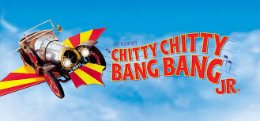
The famous high-flying car is ready to land on your stage and save the day in this Broadway Junior adaptation of the blockbuster musical and beloved classic film.

This is a Junior adaptation with a 60-minute running time.
Actors who are in grades 3-12 may audition for this production.

Take a fantastic musical adventure with an out-of-this-world car that flies through the air and sails the seas. Based on the record-breaking West End production and the beloved film, and featuring an unforgettable score by the Sherman Brothers (Mary Poppins), Chitty Chitty Bang Bang JR. is one blockbuster that audiences will find "Truly Scrumptious."
Eccentric inventor, Caractacus Potts, sets about restoring an old race car with the help of his children Jeremy and Jemima. They soon discover the car is magic, and has the ability to float and take flight. When the evil Baron Bomburst desires the magic car for himself, the family joins forces with Truly Scrumptious and Grandpa Potts to outwit the dastardly Baron and Baroness and their villainous henchman, the Child Catcher.
Filled with amazing stage spectacle and unforgettable songs, including the Academy Award nominated title song, Chitty Chitty Bang Bang JR. is a high-flying fun-filled adventure that will dazzle audiences and Broadway Junior Stars alike.

